Comparative Evaluation of Deep Learning Architectures for Multiclass IoT Intrusion Detection on CICIoT2023: Accuracy, Per-Class Behaviour and Training Cost
Namrata Kothari
School of Computer Science and Engineering
Manipal University Jaipur, Jaipur, India

Abstract—Reported results for IoT intrusion detection on CICIoT2023 span more than 23 percentage points, yet label sets, sampling and test regimes differ so widely that the figures cannot be ranked. This paper therefore evaluates seven deep learning architectures under one controlled eight-class configuration: a DNN, DNN with Dropout, DNN with L2 regularisation, a combined regularised DNN, a GRU, an LSTM and a Transformer. All models use the same 39 standardised flow features and a balanced 80,000-flow training sample, and are tested on the supplied 268,463-flow set with its natural class distribution. Beyond accuracy, we report macro-averaged precision, recall, F1 and specificity, per-class F1 and training time. The plain DNN achieves the best accuracy (75.44%) and macro-F1 (63.46%); the L2 variant trains fastest (18.46 s) at 75.08% accuracy; and the Transformer attains the highest macro-precision (65.39%) and macro-recall (71.05%) but needs 179.6 times the DNN’s training time. The GRU outperforms the LSTM by 14.6 accuracy points. Two rare classes, BruteForce and Web-based (2.8% of test flows), score F1 below 0.30 for every model, which keeps macro-F1 9.5 to 12.0 points below accuracy. Results are single runs, so differences of one to two points are not treated as meaningful. In this setting, added architectural complexity does not improve detection, and rare-class handling rather than architecture choice is the main bottleneck.
Index Terms—CICIoT2023, class imbalance, deep learning, GRU, intrusion detection system, Internet of Things, macro-F1, Transformer.

I. Introduction
The Internet of Things (IoT) connects sensors, cameras, gateways and controllers that are often resource-constrained and widely exposed, which multiplies the entry points available to attackers. Intrusion detection systems (IDS) monitor network or host activity for malicious behaviour. Signature-based systems recognise only patterns that have already been encoded, so learning-based IDS, which learn statistical patterns directly from traffic, have become the focus of recent research [1], [2].
CICIoT2023 has emerged as a frequently used modern benchmark for this task. Published results on it are difficult to interpret, however: reported accuracy runs from 76.88% [3] to above 99.9% [4], [5], and the studies differ in label sets, sample sizes, rebalancing and test design. A reader comparing headline accuracies could conclude that the problem is nearly solved, or that some methods are far weaker than others, and neither conclusion is supported.
Accuracy alone is also a poor guide for an IDS. IoT traffic is heavily imbalanced, so a model can look acceptable overall while failing on rare attack classes; one published ensemble reached 76.88% accuracy with F1 of 0.00 on its rare classes [3]. Computational cost matters as well, because models may need frequent retraining or eventual deployment on constrained hardware.
This paper therefore asks a narrow, controlled question: under one fixed eight-class configuration and one fixed test set, how do feed-forward, recurrent and attention-based architectures compare on class-balanced metrics and on training cost? The contributions are:
- A controlled benchmark of seven architectures from three families, trained on the same preprocessed data and scored on the same natural-distribution test set with accuracy, macro-precision, macro-recall, macro-F1, macro-specificity and training time.
- A per-class analysis showing that two classes, together only 2.8% of test flows, account for the persistent gap between accuracy and macro-F1.
- A performance–cost analysis and a cautious positioning against published CICIoT2023 results that states explicitly what is and is not comparable.
The study is deliberately scoped as an internal, controlled comparison and not as a search for the best possible detector. It does not tune each model to its limit, does not include tree-based baselines, and does not claim to improve on published accuracy figures. Its value lies in holding data, split, test set and metrics constant, so that differences between architectures, and the shared failure on rare classes, can be observed without the protocol differences that confound cross-paper comparisons.
The remainder of the paper is organised as follows. Section II reviews related work. Section III describes the data and training protocol, Section IV the models, and Section V the metrics. Section VI presents results, Section VII discusses them, Section VIII lists limitations, and Section IX concludes.

II. Related Work

A. IoT Intrusion Detection and Benchmark Datasets
IDS research has moved from rule- and signature-based systems toward anomaly detection and learning-based approaches, increasingly using CNNs, LSTMs, Transformers, federated learning, explainable AI and edge deployment [1], [6]. Reviews consistently recommend reporting macro-F1, MCC and AUC-PR, together with latency, throughput and memory, rather than accuracy alone [1]. As described in the literature, CICIoT2023 was collected from 105 IoT devices and contains 47 features, 33 attack types plus benign traffic (34 classes) and about 45.8 million flows with extreme class imbalance [4], [7]. Because the full label space is large, studies derive binary, 6-, 8-, 20- and 34-class tasks from the same data, which complicates comparison.
Older benchmarks such as KDD-Cup’99, NSL-KDD and UNSW-NB15 remain in use [8], [6], although KDD-Cup’99 in particular is criticised as outdated and synthetic. Other datasets in the literature include TON_IoT [5], N-BaIoT and BoT-IoT [9], IoT-23 [10], CICIDS2018 [11] and CIC-IDS2017 [6], together with newer collections such as ROAD, Edge-IIoT-2022, CICIoMT2024, CREMEv2 and RT-IoT2022 [1]. CICIoT2023 was listed by 12 of the 20 studies compiled for this work and used by 10 of its 11 experimental studies [12].
Table I lists the compiled corpus: eight reviews and surveys, eleven experimental studies and one benchmark, of which 16 are published articles [12]. The other four are not standard journal articles: a conference paper [3], an MSc project [13], a preprint [9] and a paper with no stated venue or date [14]. One experimental study [15] addresses mobile social networks using simulated data rather than IoT benchmark data; it is retained for completeness but contributes little to the CICIoT2023 analysis.
TABLE I
Studies in the Compiled Corpus
Ref. | Study | Year | Type | CICIoT2023
[1] | Poltoratskyi & Gavrylenko | 2026 | Review | Discussed
[15] | Rivandi & Oskouei | 2025 | Experimental (NS2) | No
[8] | Meena & Indian | 2025 | Experimental | Yes
[3] | Kwari & Rajkumar | 2025 | Experimental | Yes
[14] | Salakhutdinov | n.d. | Review | Discussed
[10] | Imran et al. | 2026 | Experimental | Yes
[4] | Hajjouz & Avksentieva | 2024 | Experimental | Yes
[16] | Winanto & Idris | 2026 | Systematic review | Discussed
[17] | Erskine | 2025 | Experimental | Yes
[18] | Diana et al. | 2025 | Review | No
[5] | Yaras & Dener | 2024 | Experimental | Yes
[13] | Mughogho | 2025 | Experimental (MSc) | Yes
[2] | Ahmed et al. | 2026 | Systematic review | Discussed
[19] | Bunko et al. | 2026 | Survey | Discussed
[20] | Mondragon et al. | 2025 | Benchmark | Not recorded
[7] | Almahaqeri et al. | 2026 | Experimental | Yes
[11] | Khan et al. | 2026 | Experimental | Yes
[21] | Mallidi & Ramisetty | 2025 | Systematic review | No
[6] | Hozouri et al. | 2025 | Survey | No
[9] | Mishra & Reddy | 2026 | Experimental (preprint) | Yes
n.d.: no date. “Discussed”: the dataset is discussed but not used experimentally.

B. Surveys and Reviews
Two of the eight reviews follow PRISMA procedures. Winanto and Idris screened 5,890 records and included 216 studies on adversarial robustness, finding that FGSM is used in 76.9% of them and adversarial training in 61.6%, while black-box attacks and certified defences are rare and CICIoT2023 features in under 5% [16]. Ahmed et al. included 125 of 22,558 screened records from January 2022 to May 2025, identified five themes (ensemble and hybrid, context-specific, data-centric, deep architectures and trustworthiness), and report that only about 2% of papers use explainable AI, about 4% test robustness, and none validates in production [2].
The remaining reviews are narrative or targeted. Poltoratskyi and Gavrylenko build a taxonomy by detection method, deployment, data source and response, and report that accuracy above 98% is common on benchmarks while imbalance, zero-day detection, scalability and privacy remain open [1]. Salakhutdinov separates anomaly detection from intrusion classification and argues that benchmark success does not equal robustness, stressing concept drift, explainability and defence in depth, though the proposed framework is not experimentally validated [14]. Bunko et al. observe that most federated IDS work only keeps raw data local, which leaves inference and poisoning attacks open [19], whereas Mallidi and Ramisetty conclude that federated learning improves scalability and privacy and that hybrid cloud–fog–edge deployment balances resources [21]. Hozouri et al. note that deep learning improves detection of complex attacks but depends on labelled data and is hampered by imbalance and legacy datasets [6], and Diana et al. identify scalability and false alarms as persistent problems [18].

C. Boosted Trees and Feature Selection
Hajjouz and Avksentieva [4] trained CatBoost on the full 45.8 million-flow dataset after Spearman clustering reduced the features to 23, using class weights and six-fold stratified validation. They reported 99.96% accuracy on 20 classes (DoS, DDoS and Mirai subtypes plus benign) at 7.16×10⁻⁷ s per flow, with SHAP analysis; the study excludes other attack families and does not report macro-F1. Almahaqeri et al. [7] compared XGBoost, LightGBM and CatBoost on binary, eight-class and 34-class tasks after stratified undersampling and gain-based selection that halved the features from 46 to 23. XGBoost reached 99.61% binary accuracy and 0.995 macro-F1 at 0.355 µs per sample, with inference latency reduced by 30–51% and accuracy changing by no more than 0.014 points; the evaluation is undersampled and limited to one dataset.
Khan et al. [11] combined Boruta, greedy forward selection, SMOTE and LightGBM in a pipeline called BGL-RID. They obtained 98.88% on CICIoT2023, 99.94% on CICIDS2018, 99.91% on a Raspberry Pi dataset, and 99.72% binary and 98.94% multiclass on TON_IoT, with the best efficiency ratio among the compared methods. SMOTE is applied, and a small mismatch between the abstract and conclusion is noted in the corpus summary.

D. Deep Learning Studies
Meena and Indian [8] proposed a two-layer LSTM with 100 units per layer, trained for 20 epochs with Adam, and compared it with logistic regression, AdaBoost, a DNN and an RNN on KDD-Cup’99, NSL-KDD, UNSW-NB15 and CICIoT2023. They report 98.58% accuracy on 34 classes against 98.26% for the DNN and 98.25% for the RNN; figures differ between tables in the paper, and the margin over simple baselines is small. Yaras and Dener [5] combined a 1D-CNN with an LSTM in PySpark with correlation-based feature reduction and reported 99.995% binary and 99.96% multiclass accuracy on CICIoT2023 and 98.75% binary on TON_IoT, outperforming ten comparison algorithms; training on large data is long, and balancing is not recorded.
Imran et al. [10] compared six models (decision tree, random forest, XGBoost, CNN, LSTM and Transformer) on 18,000 samples with six harmonised classes drawn from CICIoT2023 and IoT-23. An LSTM was best with 96.02% accuracy, 94.69% F1 and ROC-AUC of 0.97, ahead of XGBoost, and SHAP and LIME highlighted flow duration, packet rate and bytes per second; the sample is small and the explainability evaluation is qualitative. Erskine [17] proposed a detection-and-prevention MLP trained on over 80% of CICIoT2023 that exceeded 85% accuracy with 99% precision on Mirai traffic, but evaluated prevention only through confusion-matrix values rather than a blocking test. Mishra and Reddy [9] evaluated CNN, LSTM, BiLSTM, attention, tiny Transformer, random forest, XGBoost and deep-feature XGBoost on N-BaIoT, CICIoT2023 and BoT-IoT; XGBoost-based models were strongest (0.921 accuracy, 0.858 F1, macro-averaged) and CICIoT2023 was the hardest multiclass setting, although the work is a preprint whose federated stage has not yet been run.

E. Ensembles and Benchmarks
Kwari and Rajkumar [3] evaluated a soft-voting ensemble of logistic regression, random forest and AdaBoost on a 100,000-sample subset (80,000 training and 20,000 test) with no resampling, obtaining 76.88% accuracy and 0.54 macro-F1 (weighted F1 0.74). Flooding and Mirai classes were detected at F1 near 1.00 whereas rare classes scored 0.00, a clear illustration of how accuracy hides minority-class failure. Mughogho [13] used mutual-information feature selection with decision tree, random forest, XGBoost and soft voting, reaching 99.80% binary and 99.25% multiclass accuracy; gains over the best single member were only 0.1 to 0.3 points, and members passed only 89–93% of benign flows in binary detection. Across three comparisons the ensemble gain over the best member averages 0.66 points (Table IV).
Mondragon et al. [20] benchmarked seven algorithm categories on 14 flow datasets with fixed splits using macro-F1. CFC performed best overall, followed by LCCDE and a fully connected network, and the real-traffic LITNET dataset gave the lowest scores, indicating that benchmark rankings do not transfer to realistic traffic. RBM and GNN methods were limited by tuning cost, and no single recommended subset emerged.

F. Comparability of Reported Accuracy
Across 13 CICIoT2023 results from nine experimental studies, reported accuracy spans 23.1 percentage points (76.88% to 99.995%), the median is 99.4%, and eight results (62%) are at or above 99% [12]. Only two results use a natural-distribution test set: Kwari and Rajkumar [3] at 76.88% and Hajjouz and Avksentieva [4] at 99.96%. Two entries are lower bounds only (“above 85%” [17] and “above 99.4%” [7]). The 23-point range therefore cannot be attributed to method quality, because label sets (binary to 34 classes), sample sizes (18,000 to 45.8 million), rebalancing (none, class weights, undersampling, SMOTE) and test regimes all differ. Table II lists all 13 results with the properties that matter for comparison, and Fig. 1 shows their spread.
TABLE II
Reported CICIoT2023 Accuracy by Study and Task
Study | Task | Model | Acc. (%) | Natural test
Kwari & Rajkumar [3] | 34-class | Soft-voting ens. | 76.88 | Yes
Erskine [17] | Multiclass | DLMLP | >85† | NR
Imran et al. [10] | 6-class | LSTM | 96.02 | NR
Meena & Indian [8] | 34-class | Enhanced LSTM | 98.58 | NR
Khan et al. [11] | Multiclass | LightGBM (BGL-RID) | 98.88 | NR
Mughogho [13] | Multiclass | Soft-voting ens. | 99.25 | NR
Almahaqeri et al. [7] | 34-class | Gradient boosting | >99.4† | No
Almahaqeri et al. [7] | 8-class | Gradient boosting | >99.4† | No
Almahaqeri et al. [7] | Binary | XGBoost | 99.61 | No
Mughogho [13] | Binary | Soft-voting ens. | 99.80 | NR
Yaras & Dener [5] | Multiclass | 1D-CNN + LSTM | 99.96 | NR
Hajjouz & Avks. [4] | 20-class | CatBoost | 99.96 | Yes
Yaras & Dener [5] | Binary | 1D-CNN + LSTM | 99.995 | NR
This work | 8-class | DNN | 75.44 | Yes
NR: not recorded in the text read. †Lower bound as stated by the authors. Results as reported by the original authors; setups differ and none was reproduced.
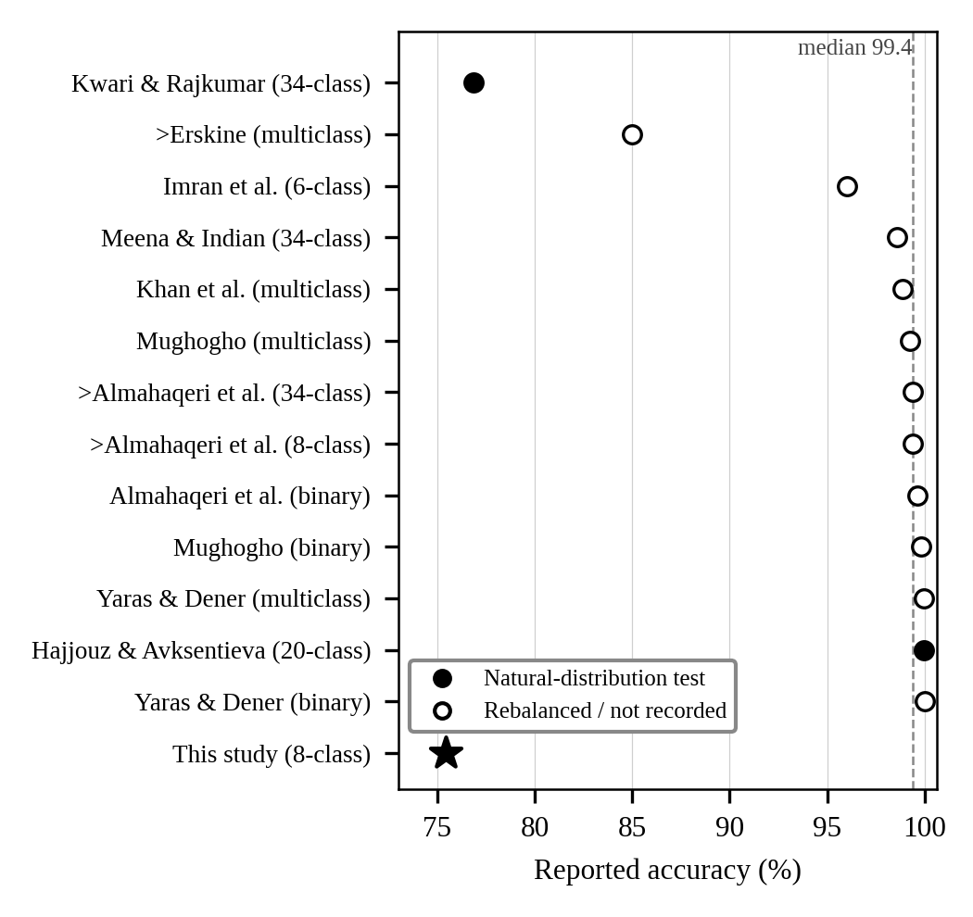
Fig. 1. Reported CICIoT2023 accuracy by study and task. Filled markers denote natural-distribution test sets; open markers denote rebalanced or unrecorded regimes. “>” marks lower bounds. The star is this study.
The best reported result also depends on the task (Table III). Binary accuracy exceeds 99.6% in all three studies reporting it, yet two of them evaluate undersampled data or leave balancing unrecorded. For the 20-class task, CatBoost on the full dataset with class weights and six-fold validation gives 99.96%, which is the closest result to a realistic evaluation among the high-accuracy figures. The two results on natural-distribution test sets that make a within-study comparison possible, 76.88% [3] and the 75.44% reported here, are far lower than the headline figures.
TABLE III
Highest Reported Accuracy by Task
Task | Acc. (%) | Study (model) | Setup caveat | Realistic?
Binary | 99.995 | Yaras & Dener (1D-CNN + LSTM) | Subset and balancing not recorded | Unclear
Binary | 99.80 | Mughogho (soft voting) | Benign recall of members only 89–93% | Unclear
Binary | 99.61 | Almahaqeri et al. (XGBoost) | Undersampled evaluation | No
8-class | >99.4 | Almahaqeri et al. (gradient boosting) | Lower bound; undersampled evaluation | No
34-class | >99.4 | Almahaqeri et al. (gradient boosting) | Lower bound; undersampled evaluation | No
34-class | 98.58 | Meena & Indian (enhanced LSTM) | Subset of about 2.54 million records | Unclear
20-class | 99.96 | Hajjouz & Avksentieva (CatBoost) | Full 45.8 M flows; stratified; six-fold validation | Closest
34-class natural | 76.88 | Kwari & Rajkumar (soft voting) | 100,000-sample subset; no rebalancing | Yes
6-class | 96.02 | Imran et al. (LSTM) | 18,000 samples from two datasets | Unclear
8-class natural | 75.44 | This study (DNN) | Own experiment; balanced training, natural 268,463-flow test | Yes
“Realistic?” indicates whether the setup resembles real traffic; “Closest” marks the nearest to a full natural-distribution evaluation among the high-accuracy results.

G. Deep Versus Tree-Based Models and Ensembles
The two head-to-head comparisons in the corpus disagree (Table IV). An LSTM led XGBoost by 3.64 points on six classes [10], whereas a deep-feature XGBoost model led a hybrid CNN-BiLSTM-attention-Transformer by 2.31 points on macro-averaged accuracy across three datasets [9]. In another study the proposed LSTM led a plain DNN by only 0.32 points [8]. The evidence therefore supports no universal winner: boosted trees have the most consistent top results at low cost, while deep models are strong mainly against weak baselines. Voting ensembles give small gains over their best member, averaging 0.66 points.
TABLE IV
Deep Versus Tree-Based Models and Ensemble Gains
Study and task | Model A (acc. %) | Model B (acc. %) | A − B (pts)
Imran et al.: 6 classes | LSTM 96.02 | XGBoost 92.38 | +3.64
Mishra & Reddy: macro avg. | Hybrid DL 89.80 | DF-XGBoost 92.11 | −2.31
Kwari & Rajkumar: 34 classes | Ensemble 76.88 | Best member 75.15 | +1.73
Mughogho: binary | Ensemble 99.80 | Best member 99.69 | +0.11
Mughogho: multiclass | Ensemble 99.25 | Best member 99.11 | +0.14
DF-XGBoost: deep-feature XGBoost. Mean ensemble gain over the best member is 0.66 points.
TABLE V
Method Families and Best Reported Results
Family | Best reported result | Typical cost
Boosted trees + feature selection | 99.96% (20 classes), 99.61% binary, 98.88% multiclass | 0.36–0.72 µs per sample; 23 features
Deep learning (CNN/LSTM hybrids) | 99.995% binary, 99.96% multiclass, 98.58% on 34 classes | 8–95 ms per detection
Voting ensembles | 76.88% (34 classes), 99.80% binary | Low
This study (MLP, GRU, LSTM, Transformer) | 75.44% (8 classes, natural test) | 18–3,498 s training, CPU
Figures as reported by the authors; setups differ.

H. Efficiency Reporting
Feature selection is a consistent lever: halving the features from 46 to 23 cut inference latency by 30–51% and training time by 33–40% with at most 0.014 points of accuracy change [7]. Cost reporting is nevertheless uneven and the units differ (Table VI). Per-sample times in batch evaluation [7], [4] cannot be compared with per-detection times of 8 ms for a decision tree up to 95 ms for a Transformer [10]; groups should be compared only within themselves. This is one reason the present study reports cost only as relative training time.
TABLE VI
Reported Inference Cost and Units
Study | Model | Reported | Basis
Almahaqeri et al. | XGBoost, 23 features | 0.355 µs | Per sample, binary, batch
Hajjouz & Avks. | CatBoost, 23 features | 0.716 µs | Per flow; test time 9.84 s
Imran et al. | Decision tree | 8 ms | Per detection
Imran et al. | Random forest | 12 ms | Per detection
Imran et al. | XGBoost | 18 ms | Per detection
Imran et al. | CNN | 45 ms | Per detection
Imran et al. | LSTM | 78 ms | Per detection
Imran et al. | Transformer | 95 ms | Per detection
The first two rows are per-sample batch times; the remaining rows are per-detection times in a different measurement setup.

I. Evidence Quality and Unestablished Capabilities
Six experimental or benchmark studies were scored on five criteria: natural-distribution testing, macro or per-class metrics, repeated runs, cost reporting and multiple datasets [12]. No study met all five and the highest score was three, which places all six in the medium band (Table VII). Scoring is based on the text read, and “not recorded” is not a finding of omission. Applying the same criteria to the present study gives two of five: natural-distribution testing and macro and per-class metrics are met, whereas repeated runs are not, cost is only partly reported (parameter counts and training time) and a single dataset is used. The study therefore also falls in the medium band.
TABLE VII
Evidence-Quality Criteria Met
Study | Nat. | Macro | Rep. | Cost | Multi | Met | Band
Kwari & Rajkumar | Yes | Yes | No | No | No | 2 | Med.
Hajjouz & Avks. | Yes | Partial | Yes | Yes | No | 3 | Med.
Almahaqeri et al. | No | Yes | NR | Yes | No | 2 | Med.
Imran et al. | NR | Partial | Yes | Yes | Yes | 3 | Med.
Khan et al. | NR | NR | NR | Yes | Yes | 2 | Med.
Mondragon et al. | NR | Yes | NR | NR | Yes | 2 | Med.
This study | Yes | Yes | No | Partial | No | 2 | Med.
Nat.: natural-distribution test; Macro: macro or per-class metrics; Rep.: repeated runs; Cost: cost reported; Multi: multiple datasets. Yes = 1; Partial, No and NR = 0. Bands: High 4–5, Medium (Med.) 2–3, Low 0–1.
Several capabilities have no established state of the art on CICIoT2023 (Table VIII). Explainability is applied qualitatively, with top features differing between studies; robustness is untested on this dataset; federated training has no validated result; no reviewed system is validated in production; and the best method changes with the dataset.
TABLE VIII
Capabilities Without an Established State of the Art
Capability | Evidence in the corpus | Status
Explainability | SHAP and LIME used [10], [4]; top features differ (flow duration, packet rate, bytes/s versus IAT, SYN flag count, total size) | Qualitative only; no fidelity or stability numbers
Adversarial robustness | Under 5% of 216 robustness studies use CICIoT2023 [16]; about 4% of ML-IDS papers test robustness [2] | No CICIoT2023 result is robustness-tested
Federated, privacy-preserving training | Federated stage of [9] not yet run; most FL-IDS work stops at data locality [19] | No validated result
Production or streaming validation | None of 125 reviewed ML-IDS papers validates in production [2] | No result
Cross-dataset generalisation | Best method changes by dataset; real-traffic LITNET scores lowest [20] | Evidence against a universal best model

J. Summary of the Literature
Three conclusions follow from the literature. First, the reported CICIoT2023 results are dominated by protocol: the two natural-distribution results differ by 23 points, and the high figures come from binary tasks, rebalanced subsets or undersampled test sets. Second, boosted trees with feature selection are the most consistent and cheapest strong performers, whereas deep models mainly win against weak baselines. Third, rare-class performance, cost and robustness are under-reported. The experiment in this paper is designed around these observations: one protocol for all models, macro and per-class metrics, a natural test set and cost reporting.

K. Gaps Addressed
Synthesising the corpus yields eleven research gaps: a standard CICIoT2023 protocol; cross-dataset generalisation; rare-class detection; fair deep-versus-tree comparisons; quantified explainability; resource-aware edge evaluation; drift and adversarial robustness; privacy beyond data locality; production and streaming validation; measured prevention and response; and realistic operational benchmarks [12]. This work addresses the first, second and fourth evidence criteria of the preceding subsection within a single controlled comparison of deep architectures: it fixes a label set, split and test set, reports macro and per-class metrics on a natural-distribution test, and reports cost, and it is explicit about the missing repeated runs. It does not address generalisation, robustness, privacy or production validation.

III. Experimental Setup

A. Dataset and Task
The study uses a derived eight-class configuration of CICIoT2023 rather than the full 34-class label space. The classes are Benign, BruteForce, DDoS, DoS, Mirai, Recon, Spoofing and Web-based. Each flow is described by 39 standardised numerical features, and the task is multiclass classification into one of the eight classes.
The full CICIoT2023 benchmark was collected from 105 IoT devices and contains 47 features, 33 attack types plus benign traffic and about 45.8 million flows [4], [7]. The experiments here use the supplied training and test files, which contain 1,073,851 and 268,463 rows respectively, with 39 numerical features retained. The eight classes are benign traffic and seven attack categories. Because the attack categories differ greatly in size in the natural data, a derived configuration with a balanced training pool lets each architecture see every class equally often, while the natural test set exposes how that choice transfers to realistic class proportions.

B. Data Preparation
Before sampling, 84,370 duplicate training rows were removed. A training pool of 10,000 flows per class (80,000 in total) was drawn and split 80/20 in a stratified manner into 64,000 training and 16,000 validation flows (random_state 42). A StandardScaler was fitted on the training part only. The test set comprises 268,463 flows used exactly as supplied, with its natural class distribution, and was neither resampled nor de-duplicated (Table IX).
TABLE IX
Test Set Composition (268,463 Flows)
Class | Flows | Share (%) | Class | Flows | Share (%)
Benign | 39,998 | 14.90 | Recon | 40,380 | 15.04
BruteForce | 2,607 | 0.97 | Spoofing | 19,956 | 7.43
DDoS | 90,353 | 33.66 | Web-based | 5,008 | 1.87
DoS | 40,067 | 14.92 | Mirai | 30,094 | 11.21
Training and validation data are class-balanced (12.5% per class); the test set is not.
The mismatch between a balanced training pool and an imbalanced test set is deliberate: it mirrors a realistic deployment in which training data are rebalanced but traffic is not, and it is the main reason why class-balanced metrics are reported.

C. Training Protocol
The DNN variants, GRU and LSTM were trained for up to 20 epochs and the Transformer for up to 25. Early stopping and learning-rate reduction were used for the Proposed DNN, GRU, LSTM and Transformer, but not for the plain DNN, DNN with Dropout or DNN with L2. All models were trained on CPU only with TensorFlow 2.21.0, and the recorded training times include a validation pass at every epoch. Each model was run once, no seed was fixed for model weights, and no significance test was performed.

D. Research Questions and Workflow
Five research questions guide the evaluation. RQ1: which architecture gives the best predictive performance? RQ2: do Dropout and L2 regularisation improve the baseline DNN? RQ3: how do GRU and LSTM compare with the feed-forward models? RQ4: does the Transformer justify its additional computational cost? RQ5: which methodological factors must be considered before comparing the results with published CICIoT2023 figures? The workflow comprises data preparation, class balancing of the training pool, a stratified train–validation split, feature scaling, model construction, training, test evaluation and cross-model comparison. Every model passes through the same pipeline, so observed differences are attributable mainly to architecture and training configuration, subject to the budget differences discussed in Section VIII.

E. Reproducibility
Reproduction requires the exact feature list, preprocessing pipeline, class mapping, split generation, model definitions, optimiser settings, batch size, epoch counts and hardware, because small implementation differences can change neural-network results. The split seed (42), the scaler fitting rule and the framework version (TensorFlow 2.21.0) are fixed in this study. Weight initialisation was not seeded, so repeating the experiment will give slightly different numbers, which is a further reason to avoid interpreting gaps of one to two points.

IV. Models
The seven models represent three families: dense feed-forward networks, recurrent networks and an attention-based Transformer (Table X). The DNN variants receive the 39-feature vector directly. The first three share the same layer sizes and therefore the same parameter count (15,720), so that their differences isolate the effect of regularisation: Dropout (rate 0.30), L2 weight decay (0.001), and, for the Proposed DNN, a combination of L2, batch normalisation and Dropout (0.30, 0.30, 0.20).
The GRU and LSTM reshape the input to 39 timesteps with one value per step. This ordering of tabular features is a modelling choice and not an observed time order. The Transformer tokenises each feature into a 64-dimensional embedding with learnable position embeddings and a learnable CLS token, and processes them with two pre-normalised encoder blocks of four attention heads each. Its classification head is a Dense(64, GELU) layer, Dropout (0.15) and a softmax output. It is trained with AdamW (learning rate 1e-4, weight decay 1e-4).
The families were chosen to represent the main designs used in the reviewed studies. Dense networks are the simplest deep baseline and are the comparison model in several studies [8]. Recurrent networks, especially LSTMs, are the most frequently reported deep architecture for this dataset [8], [10], [5]. Transformer-style models appear in comparisons [10], [9] but are rarely reported with their cost. Including all three under one protocol allows the extra expressiveness of each family to be weighed against its training cost.
TABLE X
Model Architectures
Model | Architecture (input 39 features; softmax-8 output) | Params
DNN | 128 → 64 → 32 | 15,720
DNN + Dropout | 128 → Drop(0.30) → 64 → Drop(0.30) → 32 | 15,720
DNN + L2 | 128 (L2 = 0.001) → 64 (L2 = 0.001) → 32 | 15,720
Proposed DNN | 128 (L2) → BN → Drop(0.30) → 64 (L2) → Drop(0.30) → 32 → Drop(0.20) | 16,232
GRU | 39×1 → GRU(64) → Drop(0.20) → GRU(32) → Dense(64) → Drop(0.20) | 24,904
LSTM | 39×1 → LSTM(64) → Drop(0.30) → LSTM(32) → Drop(0.30) → Dense(64) | 31,944
Transformer | Tokeniser(64) → pos. emb. → CLS → 2 encoder blocks (4 heads) → Dense(64, GELU) → Drop(0.15) | 76,808
BN: batch normalisation; Drop: Dropout; Params: total parameters. The 512-parameter difference between the Proposed DNN and the DNN equals four parameters per unit of the 128-unit batch-normalisation layer. Layer-wise counts are given in Appendix A.

V. Evaluation Metrics
Let K = 8 be the number of classes, and let TP, FP, FN and TN denote per-class true positives, false positives, false negatives and true negatives. Per-class precision and recall are P_{k} = TP_{k} / (TP_{k} + FP_{k}) and R_{k} = TP_{k} / (TP_{k} + FN_{k}). The per-class F1 score and its macro average are
F_{1,k} = 2P_{k}R_{k} / (P_{k} + R_{k}) (1)
Macro-F1 = (1/K) Σ_{k=1}^{K} F_{1,k} (2)
Macro-precision and macro-recall are defined analogously, and macro-specificity averages
Spec_{k} = TN_{k} / (TN_{k} + FP_{k}) (3)
over classes. Because each class has equal weight, macro metrics expose rare-class failure that accuracy hides. Training time is wall-clock time on CPU and is used as a relative indicator of training and retraining cost; it is not inference latency. Metric values are those recorded by the experiment’s classification reports.
Choice of metrics. Accuracy is reported for comparability with the literature, in which it is the dominant figure. Macro-averaged precision, recall and F1 are reported because every class carries equal weight and rare-class failure becomes visible, as recommended in recent reviews [1]. Macro-specificity is included to reflect false alarms in aggregate, although it varies little here (93.73% to 96.51%) and is a weak discriminator. Matthews correlation coefficient and AUC-PR, which the same reviews recommend, were not computed because only the classification reports were retained; adding them is a straightforward extension. In the corpus only two studies report macro-F1 alongside accuracy on CICIoT2023 [3], [7], so the macro-averaged values here have few direct points of comparison.
Sampling uncertainty. With 268,463 test flows and an accuracy near 0.75, the binomial standard error of accuracy is about 0.08 percentage points, giving a 95% interval of roughly ±0.16 points if flows are treated as independent. This quantifies only test-set sampling error. Flows from the same capture session are likely correlated, so the true interval is wider, and it does not include run-to-run variation from random weight initialisation, which was not measured. The test-sampling error is therefore a lower bound on the uncertainty, and it is much smaller for the large classes than for BruteForce (2,607 flows) or Web-based (5,008 flows).

VI. Results

A. Overall Performance
Table XI and Fig. 2 summarise test-set performance. The plain DNN achieves the highest accuracy (75.44%), macro-F1 (63.46%) and macro-specificity (96.51%). DNN + L2 follows closely (75.08%, 63.05%). The Transformer ranks fifth on accuracy (72.53%) but third on macro-F1 (62.63%), and records the highest macro-precision (65.39%) and macro-recall (71.05%). The GRU reaches 69.82% accuracy and 58.68% macro-F1, while the LSTM is clearly weakest at 55.24% and 45.71%.
TABLE XI
Test-Set Performance of the Seven Models (%)
Model | Acc. | M-Prec. | M-Rec. | M-F1 | M-Spec.
DNN | 75.44 | 64.03 | 70.31 | 63.46 | 96.51
DNN + Dropout | 73.73 | 63.91 | 69.02 | 62.10 | 96.27
DNN + L2 | 75.08 | 63.43 | 68.96 | 63.05 | 96.40
Proposed DNN | 74.07 | 64.51 | 68.98 | 62.26 | 96.33
GRU | 69.82 | 60.34 | 65.51 | 58.68 | 95.76
LSTM | 55.24 | 52.20 | 51.43 | 45.71 | 93.73
Transformer | 72.53 | 65.39 | 71.05 | 62.63 | 96.13
M-: macro-averaged. Best value per column in bold. Single run per model.
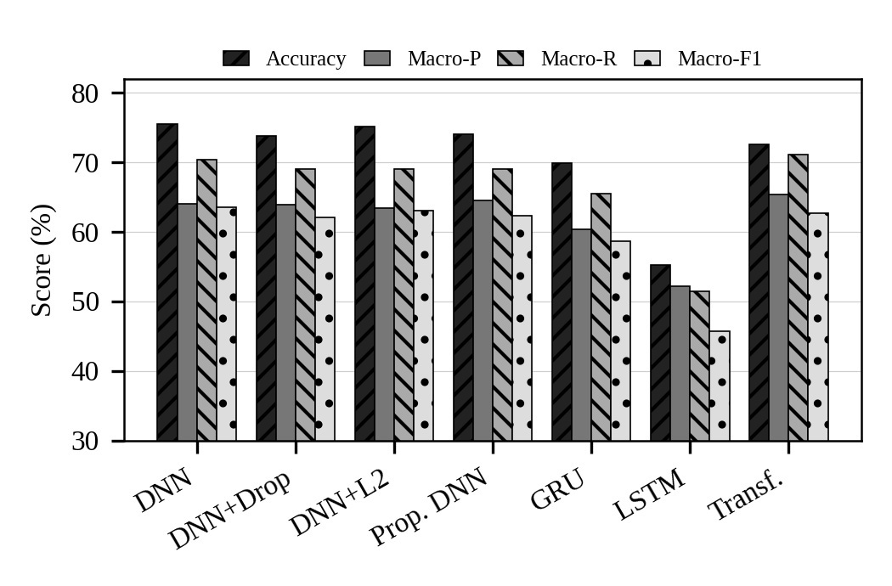
Fig. 2. Accuracy and macro-averaged precision, recall and F1 for the seven models on the 268,463-flow test set.
Two features of these results deserve emphasis. First, five of the seven models (DNN, DNN + L2, Transformer, Proposed DNN and DNN + Dropout) lie within 1.4 points of one another on macro-F1 (62.10% to 63.46%). With one unseeded run per model, this spread is too small to establish a ranking within that group. Second, macro-F1 is below accuracy for every model, by 9.5 points (LSTM) to 12.0 points (DNN + L2), which points to weak performance on some classes rather than a uniform shortfall.
Table XII lists the best model on each metric. No single model leads everywhere: the DNN takes accuracy, macro-F1 and macro-specificity, the Transformer takes macro-precision and macro-recall, and DNN + L2 is the fastest. By rank, the DNN is first on accuracy and macro-F1, DNN + L2 second on both, and the LSTM last on both; the Transformer is fifth on accuracy but third on macro-F1, the largest rank difference between the two metrics for any model.
TABLE XII
Best Model on Each Metric
Metric | Value | Model
Accuracy | 75.44% | DNN
Macro-precision | 65.39% | Transformer
Macro-recall | 71.05% | Transformer
Macro-F1 | 63.46% | DNN
Macro-specificity | 96.51% | DNN
Shortest training time | 18.46 s | DNN + L2
Rank by accuracy: DNN 1, L2 2, Proposed 3, Dropout 4, Transformer 5, GRU 6, LSTM 7. Rank by macro-F1: DNN 1, L2 2, Transformer 3, Proposed 4, Dropout 5, GRU 6, LSTM 7.

B. Training Cost
Training cost varies far more than predictive quality (Table XIII and Fig. 3). DNN + L2 is the fastest model at 18.46 s, and the four feed-forward models train in 18 to 26 s. The LSTM needs 173.61 s, the GRU 668.69 s and the Transformer 3,497.91 s (about 58 minutes), which is 179.6 times the DNN. The Transformer’s extra cost does not buy higher accuracy or macro-F1: it is 2.91 accuracy points and 0.83 macro-F1 points below the DNN, while exceeding it by 1.36 points on macro-precision and 0.74 points on macro-recall.
TABLE XIII
Model Size and Training Cost (CPU)
Model | Params | Time (s) | × DNN
DNN | 15,720 | 19.48 | 1.00
DNN + Dropout | 15,720 | 21.84 | 1.12
DNN + L2 | 15,720 | 18.46 | 0.95
Proposed DNN | 16,232 | 25.70 | 1.32
GRU | 24,904 | 668.69 | 34.33
LSTM | 31,944 | 173.61 | 8.91
Transformer | 76,808 | 3,497.91 | 179.56
Wall-clock time including a validation pass each epoch; not inference latency.
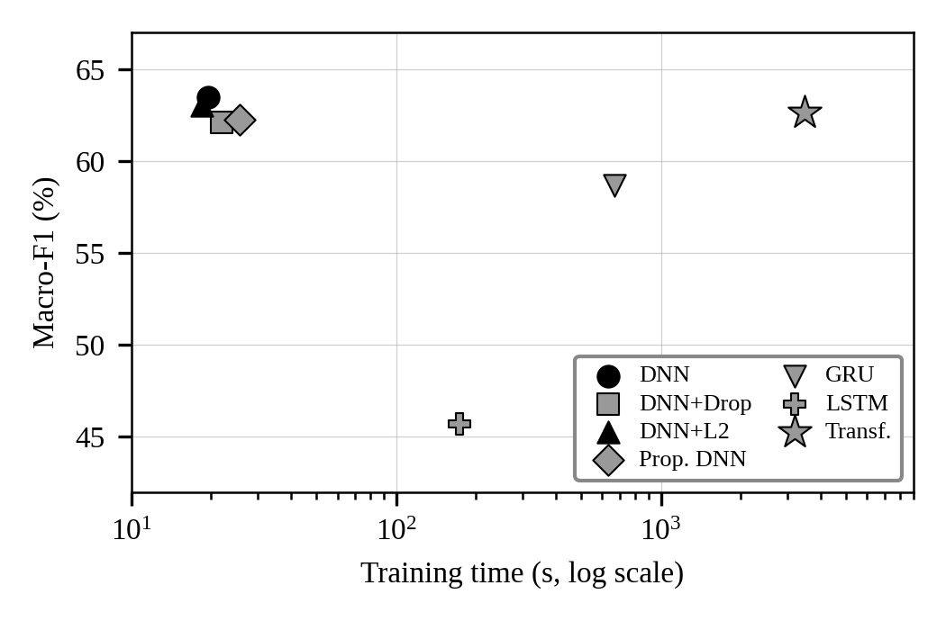
Fig. 3. Macro-F1 versus training time (log scale). The four feed-forward models cluster at top left; the two fastest are also the strongest on macro-F1 and accuracy.
Training times depend on the number of epochs actually run, which differs between models under early stopping, and the GRU and Transformer ended at their epoch limit with validation loss still falling. The times are therefore indicative of retraining cost under this protocol, not a pure property of each architecture, and the GRU and Transformer results may be limited by their training budget. The saved training log for the LSTM shows only 5 of its 20 epochs, which is consistent with early stopping ending its training early. The LSTM’s shorter time than the GRU, despite having more parameters, and its weak scores should therefore be read as partly reflecting an under-trained model, and the GRU–LSTM contrast should not be attributed to cell type alone.

C. Per-Class Behaviour
Fig. 4 gives per-class F1 for every model. Mirai is detected almost perfectly (F1 0.99 to 1.00) by every model except the LSTM (0.96), and DDoS is well handled (0.83 to 0.88) by all but the LSTM (0.59). Mid-range classes are weaker: Benign reaches only 0.54 to 0.68, DoS 0.60 to 0.77 and Recon 0.43 to 0.61. BruteForce and Web-based are the failure cases, with F1 between 0.08 and 0.27 for all models.
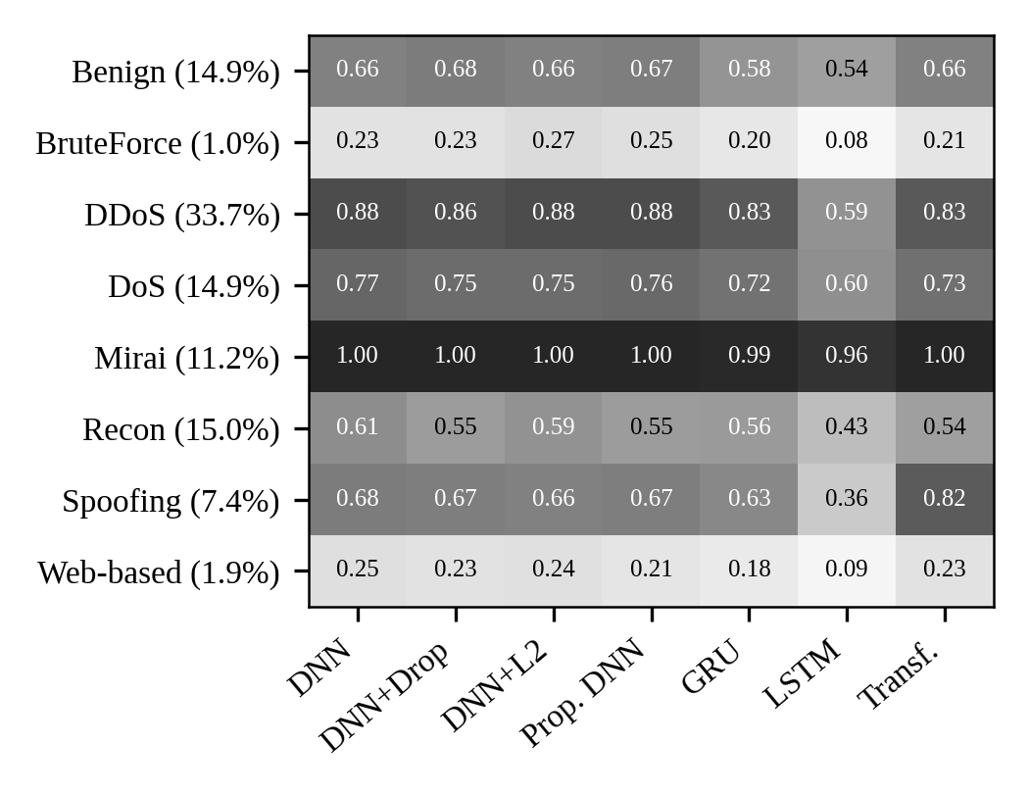
Fig. 4. Per-class F1 on the test set; the share of test flows is given beside each class label.
The Transformer’s profile differs from that of the DNN family. Its largest advantage is on Spoofing (F1 0.82 versus 0.63 to 0.68 for all other models except the LSTM at 0.36), whereas it trails the DNN on DDoS (0.83 versus 0.88) and Recon (0.54 versus 0.61). Its higher macro-recall is therefore driven in part by one class and does not reflect uniformly better detection.

D. Rare Classes
BruteForce and Web-based together make up only 2.8% of test flows, but every model scores F1 below 0.30 on both (Table XIV). In all fourteen model–class cases, precision is lower than recall: precision ranges from 0.04 to 0.18 while recall ranges from 0.13 to 0.63. For the DNN, a BruteForce precision of 0.15 at recall 0.57 implies on the order of 8,000 non-BruteForce flows labelled as BruteForce, estimated from the rounded values. This pattern is consistent with the shift from a balanced training pool, where each class is 12.5% of the data, to a test set where these classes are about 1% and 2%: models that recover many true rare-class flows also raise many false alarms from the large classes. We did not test this explanation directly.
TABLE XIV
Precision and Recall on the Rare Classes
Model | BF P | BF R | WB P | WB R
DNN | 0.15 | 0.57 | 0.16 | 0.58
DNN + Dropout | 0.15 | 0.55 | 0.14 | 0.58
DNN + L2 | 0.18 | 0.52 | 0.15 | 0.56
Proposed DNN | 0.16 | 0.52 | 0.13 | 0.63
GRU | 0.12 | 0.48 | 0.11 | 0.53
LSTM | 0.04 | 0.47 | 0.07 | 0.13
Transformer | 0.13 | 0.62 | 0.14 | 0.63
BF: BruteForce (0.97% of test flows); WB: Web-based (1.87%); P: precision; R: recall.

E. Per-Class F1 in Detail
Table XV gives the numerical values behind Fig. 4. The unweighted mean of the eight class F1 values (0.635 for the DNN, 0.631 for DNN + L2, 0.628 for the Transformer, 0.624 for the Proposed DNN, 0.621 for DNN + Dropout, 0.586 for the GRU and 0.456 for the LSTM) agrees with the reported macro-F1 to within rounding, since the per-class values are given to two decimals.
TABLE XV
Per-Class F1 on the Test Set
Class | DNN | Drop | L2 | Prop. | GRU | LSTM | Trans.
Benign | 0.66 | 0.68 | 0.66 | 0.67 | 0.58 | 0.54 | 0.66
BruteForce | 0.23 | 0.23 | 0.27 | 0.25 | 0.20 | 0.08 | 0.21
DDoS | 0.88 | 0.86 | 0.88 | 0.88 | 0.83 | 0.59 | 0.83
DoS | 0.77 | 0.75 | 0.75 | 0.76 | 0.72 | 0.60 | 0.73
Mirai | 1.00 | 1.00 | 1.00 | 1.00 | 0.99 | 0.96 | 1.00
Recon | 0.61 | 0.55 | 0.59 | 0.55 | 0.56 | 0.43 | 0.54
Spoofing | 0.68 | 0.67 | 0.66 | 0.67 | 0.63 | 0.36 | 0.82
Web-based | 0.25 | 0.23 | 0.24 | 0.21 | 0.18 | 0.09 | 0.23
Mean | 0.635 | 0.621 | 0.631 | 0.624 | 0.586 | 0.456 | 0.628
Drop: DNN + Dropout; L2: DNN + L2; Prop.: Proposed DNN; Trans.: Transformer. Mean is the unweighted mean of the eight values.
Two observations follow. The DNN-family models are almost interchangeable class by class, with differences of at most 0.06 on any class; the largest is Recon, where the plain DNN (0.61) leads the Dropout and Proposed variants (0.55). And the LSTM’s deficit is broad, not confined to rare classes: it loses 0.17 to 0.32 F1 against the DNN on DoS, Recon, DDoS and Spoofing, indicating that its sequence representation fails more generally rather than only on minority classes.
Table XVI subtracts the DNN’s per-class F1 from that of each other model. Of the 48 model–class entries, only five are positive: DNN + Dropout on Benign (+0.02), DNN + L2 on BruteForce (+0.04), the Proposed DNN on Benign (+0.01) and BruteForce (+0.02), and the Transformer on Spoofing (+0.14). Nine are exactly zero, four of them on Mirai, and the remaining 34 are negative. The only gain larger than 0.05 is the Transformer’s on Spoofing, and the only losses larger than 0.10 belong to the LSTM.
TABLE XVI
Per-Class F1 Relative to the DNN
Class | Drop | L2 | Prop. | GRU | LSTM | Trans.
Benign | +0.02 | 0.00 | +0.01 | −0.08 | −0.12 | 0.00
BruteForce | 0.00 | +0.04 | +0.02 | −0.03 | −0.15 | −0.02
DDoS | −0.02 | 0.00 | 0.00 | −0.05 | −0.29 | −0.05
DoS | −0.02 | −0.02 | −0.01 | −0.05 | −0.17 | −0.04
Mirai | 0.00 | 0.00 | 0.00 | −0.01 | −0.04 | 0.00
Recon | −0.06 | −0.02 | −0.06 | −0.05 | −0.18 | −0.07
Spoofing | −0.01 | −0.02 | −0.01 | −0.05 | −0.32 | +0.14
Web-based | −0.02 | −0.01 | −0.04 | −0.07 | −0.16 | −0.02
Differences in F1 (not percentage points); computed from the two-decimal values in the per-class table.
Taking the classes in turn clarifies where the models differ. Benign (14.9% of test flows) reaches F1 between 0.54 (LSTM) and 0.68 (DNN + Dropout), with the Transformer at 0.66; no model separates normal from malicious traffic well. BruteForce (0.97%) lies between 0.20 and 0.27 for every model except the LSTM (0.08), with DNN + L2 highest at 0.27. DDoS (33.7%, the largest class) is handled well, 0.83 to 0.88, by every model except the LSTM (0.59). DoS (14.9%) falls between 0.72 and 0.77 for all but the LSTM (0.60). Mirai (11.2%) is essentially solved, at 0.99 to 1.00, except for the LSTM (0.96). Recon (15.0%) ranges from 0.54 to 0.61 for all but the LSTM (0.43), with the plain DNN highest. Spoofing (7.4%) is the class on which the models separate most: 0.63 to 0.68 for the DNN family and the GRU, 0.82 for the Transformer and 0.36 for the LSTM. Web-based (1.9%) lies between 0.18 and 0.25 for all but the LSTM (0.09).
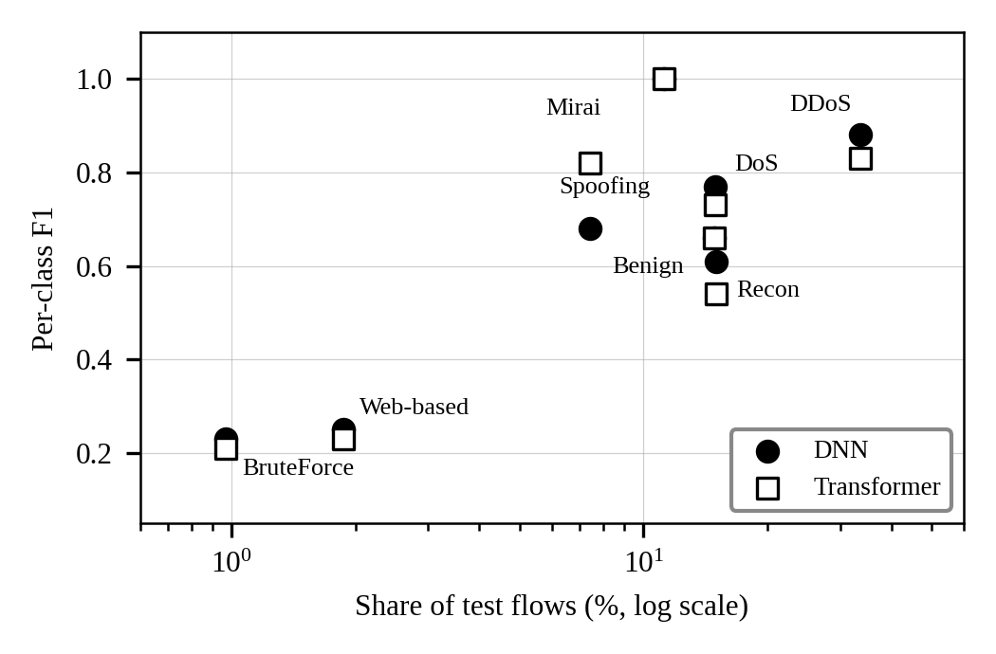
Fig. 5. Per-class F1 against the share of test flows for the DNN (filled circles) and the Transformer (open squares).
Fig. 5 relates class performance to prevalence in the test set. The two smallest classes have the lowest F1, but prevalence alone does not explain performance: Mirai (11.2%) is detected almost perfectly, whereas Benign (14.9%) and Recon (15.0%), which are larger, reach only 0.54 to 0.68 and 0.54 to 0.61. Separability of the classes in feature space therefore matters in addition to prevalence, although this was not analysed directly.

F. Effect of Regularisation and Architecture Family
Table XVII expresses every model relative to the plain DNN. The three regularised DNNs all lose between 0.36 and 1.71 accuracy points and between 0.41 and 1.36 macro-F1 points while training between 0.95 and 1.32 times as long. The recurrent and attention models lose more accuracy and cost far more to train; only the Transformer comes within 1 macro-F1 point of the baseline (−0.83), and it exceeds the DNN on macro-precision (+1.36) and macro-recall (+0.74). The Proposed DNN also exceeds it on macro-precision (+0.48).
TABLE XVII
Change Relative to the Plain DNN
Model | Δ Acc. (pts) | Δ M-F1 (pts) | Time (× DNN)
DNN + Dropout | −1.71 | −1.36 | 1.12
DNN + L2 | −0.36 | −0.41 | 0.95
Proposed DNN | −1.37 | −1.20 | 1.32
GRU | −5.62 | −4.78 | 34.33
LSTM | −20.20 | −17.75 | 8.91
Transformer | −2.91 | −0.83 | 179.56
Negative values indicate lower scores than the DNN (75.44% accuracy, 63.46% macro-F1, 19.48 s).

G. Pairwise Comparisons
Table XVIII collects the pairwise contrasts that answer the research questions on recurrence and attention. The GRU holds a large and consistent lead over the LSTM, at under four times the training time. The Transformer improves on the GRU by 2.71 accuracy points, 3.95 macro-F1 points and 5.54 macro-recall points, at 5.2 times the cost, but both remain below the DNN.
TABLE XVIII
Pairwise Differences (First Minus Second)
Comparison | Acc. | M-F1 | M-Rec. | Time ratio
Transformer vs GRU | +2.71 | +3.95 | +5.54 | 5.23×
GRU vs LSTM | +14.58 | +12.97 | +14.08 | 3.85×
Transformer vs DNN | −2.91 | −0.83 | +0.74 | 179.56×
GRU vs DNN | −5.62 | −4.78 | −4.80 | 34.33×
Differences in percentage points. Time ratio is the first model’s training time divided by the second’s.

H. Accuracy Versus Macro-F1
Table XIX makes the accuracy–macro-F1 gap explicit. It is between 9.5 and 12.0 points for every model, and it is smallest for the LSTM (9.53) and the Transformer (9.90). For the LSTM this reflects lower accuracy rather than better rare-class results; for the Transformer it reflects its higher macro-recall relative to its accuracy. Macro-specificity is high for all models (93.73% to 96.51%) and varies little, because each class is a small share of the negatives for every other class; it is therefore a weak discriminator here compared with macro-F1.
TABLE XIX
Gap Between Accuracy and Macro-F1 (%)
Model | Acc. | M-F1 | Gap | M-Spec.
DNN | 75.44 | 63.46 | 11.98 | 96.51
DNN + Dropout | 73.73 | 62.10 | 11.63 | 96.27
DNN + L2 | 75.08 | 63.05 | 12.03 | 96.40
Proposed DNN | 74.07 | 62.26 | 11.81 | 96.33
GRU | 69.82 | 58.68 | 11.14 | 95.76
LSTM | 55.24 | 45.71 | 9.53 | 93.73
Transformer | 72.53 | 62.63 | 9.90 | 96.13
Gap = accuracy − macro-F1.

I. Summary of Results
The principal results can be stated briefly:
- The plain DNN is best on accuracy (75.44%), macro-F1 (63.46%) and macro-specificity (96.51%); the Transformer is best on macro-precision (65.39%) and macro-recall (71.05%).
- Five of seven models lie within 1.4 macro-F1 points, so the data do not support a ranking among them.
- Training cost spans a factor of about 190, from 18.46 s (DNN + L2) to 3,497.91 s (Transformer), with no matching gain in aggregate quality.
- No regularised variant improved on the baseline; the GRU outperformed the LSTM by 14.58 accuracy points, and the LSTM log covers only 5 of 20 epochs.
- BruteForce and Web-based score F1 below 0.30 for every model, with precision always below recall and many thousands of implied false alarms.
- The Transformer’s Spoofing F1 of 0.82 is the only gain over the DNN larger than 0.05 on any class.

VII. Discussion

A. Findings by Research Question
Best architecture. The plain DNN is best on accuracy, macro-F1 and macro-specificity, and the Transformer on macro-precision and macro-recall. The margins are small, and the top five models are within 1.4 macro-F1 points, so the evidence supports “feed-forward models are at least as good as the others here” more strongly than “the DNN is best.”
Regularisation. None of the three regularised variants improved on the baseline DNN: accuracy changed by −0.36 (L2), −1.37 (Proposed) and −1.71 (Dropout) points, and macro-F1 by −0.41, −1.20 and −1.36. The first three models have identical parameter counts, so these differences reflect regularisation and optimisation rather than capacity. They are small and come from single runs, and they show only that the chosen strengths gave no benefit, not that regularisation is ineffective.
Recurrent versus feed-forward. The GRU outperforms the LSTM by 14.58 accuracy points, 12.97 macro-F1 points and 14.08 macro-recall points, but both trail the DNN (GRU by 5.62 accuracy and 4.78 macro-F1 points; LSTM by 20.20 and 17.75). Since the sequence is an arbitrary ordering of tabular features, there is no reason to expect recurrence to help, and the results give no evidence that it does. The LSTM’s saved log covers only 5 of 20 epochs, so part of its deficit may reflect under-training rather than the architecture.
Transformer. Relative to the DNN, the Transformer costs 179.6 times as much to train and is lower on accuracy and macro-F1. On aggregate metrics its cost is not justified in this setting. Its Spoofing result suggests it captures some structure the DNN misses, which would be worth examining in a hybrid or ensemble, but its 25-epoch budget may also have limited it.
Table XX condenses the answers and attaches an assessment of how firmly the evidence supports each, which is limited throughout by the single-run design.
TABLE XX
Summary of Findings by Research Question
RQ | Finding | Assessment of evidence
RQ1 | DNN best on accuracy, macro-F1, specificity; Transformer best on macro-precision and macro-recall. | Weak: top five models within 1.4 macro-F1 points; one run each.
RQ2 | No regularised variant beat the baseline (−0.36 to −1.71 accuracy points). | Weak to moderate: consistent direction but small gaps; single run.
RQ3 | GRU beat LSTM by 14.58 accuracy points; both below the DNN. | Moderate for direction; the LSTM log covers 5 of 20 epochs.
RQ4 | Transformer: −2.91 accuracy, −0.83 macro-F1, 179.6× cost versus the DNN. | Moderate; the Transformer may be budget-limited.
RQ5 | Headline figures are not comparable; the nearest natural-test reference is 76.88% on 34 classes. | Strong: protocol differences are documented across studies.

B. Position Against the Literature
The closest published point of reference is the natural-distribution, unmitigated ensemble of Kwari and Rajkumar [3], with 76.88% accuracy and macro-F1 of 0.54 on 34 classes. The present best result (75.44% accuracy, 0.63 macro-F1 on 8 classes) is of a similar magnitude, but the class counts differ, so the two should not be ranked. What they share is the signature of accuracy overstating rare-class performance. Results above 99% [4], [5], [7], [8] use different tasks, rebalancing or test designs (Table II), and the 24-point gap to this work should not be read as a deficit in method quality. Because tree-based models are the most consistent top performers in the literature [4], [7], [11] and none is included here, this study also cannot say how the deep models compare with them under this protocol.
Table XXI quantifies the positions discussed above. The best accuracy here is 23.96 points below the highest eight-class accuracy in the review, but that figure is a lower bound from an undersampled test set; it is only 1.44 points below the lowest natural-distribution result; and its macro-F1 is 9.46 points above the only natural-distribution result that reports macro-F1, although that study used 34 classes.
TABLE XXI
Position Against Published CICIoT2023 Results
Comparison | This study | Literature | Diff. (pts)
Best accuracy vs highest 8-class accuracy [7] | 75.44 | >99.4 | −23.96
Best accuracy vs lowest natural-distribution result [3] | 75.44 | 76.88 | −1.44
Best accuracy vs highest natural-distribution result [4] | 75.44 | 99.96 | −24.52
Best accuracy vs median of 13 reported results | 75.44 | 99.4 | −23.96
Best macro-F1 vs Kwari & Rajkumar macro-F1 [3] | 63.46 | 54.00 | +9.46
Setups differ (labels, sampling, test regime); the table shows where this study sits, not which method is better.

C. Model-by-Model Interpretation
DNN. The best model on accuracy (75.44%), macro-F1 (63.46%) and macro-specificity (96.51%), and the second fastest to train (19.48 s). It is the strongest overall baseline in this experiment and sets the reference for all other comparisons.
DNN + Dropout. Competitive but 1.71 accuracy points and 1.36 macro-F1 points below the baseline, at 21.84 s. The selected dropout rate of 0.30 gave no advantage in this run, and its Recon F1 (0.55) is 0.06 below the DNN’s.
DNN + L2. Nearly matches the DNN (75.08% accuracy, 63.05% macro-F1) while being the fastest model at 18.46 s, and attains the highest BruteForce F1 (0.27) and BruteForce precision (0.18). It is the most attractive option when training efficiency is prioritised.
Proposed DNN. Combining L2, batch normalisation and Dropout yields 74.07% accuracy and 62.26% macro-F1 at 25.70 s (1.32 times the DNN). It has the highest macro-precision among the DNN-family models (64.51%) but does not exceed the simpler variants on the headline metrics.
GRU. The stronger recurrent model: it beats the LSTM on all four predictive metrics (69.82% accuracy, 58.68% macro-F1) but needs 668.69 s, 34 times the DNN. It ended at its epoch limit with validation loss still falling, so a longer budget might narrow its gap to the DNN.
LSTM. The weakest model (55.24% accuracy, 45.71% macro-F1), with the lowest F1 on every class. Its saved log covers only 5 of 20 epochs, so under-training is a plausible contributor; its 173.61 s is not evidence that the architecture is cheap.
Transformer. The highest macro-precision (65.39%) and macro-recall (71.05%), the highest Spoofing F1 (0.82) and the highest rare-class recall for BruteForce (0.62), but 72.53% accuracy, 62.63% macro-F1 and 3,497.91 s of training. It is a candidate when recall matters and cost does not, and a poor efficiency choice under the present training configuration.

D. Ranking Stability Across Metrics
Rankings are stable at the extremes and unstable in the middle. The DNN and DNN + L2 hold the first two places on both accuracy and macro-F1, and the GRU and LSTM hold the last two on both. The four models in between change order: the Transformer is fifth on accuracy but third on macro-F1, whereas DNN + Dropout is fourth on accuracy and fifth on macro-F1 and the Proposed DNN is third on accuracy and fourth on macro-F1. Since these middle models lie within 1.4 macro-F1 points and within 2.9 accuracy points of each other, their order depends on the metric chosen, and any claim of superiority among them would need repeated runs. A practitioner whose priority is catching more attacks would favour the Transformer on macro-recall (71.05%), whereas one whose priority is aggregate correctness and low training cost would favour the DNN or DNN + L2; the metrics encode different priorities and no model dominates.

E. Practical Implications
For frequent retraining or constrained environments, the DNN and DNN + L2 reach the best aggregate scores in under 20 s, versus about 58 minutes for the Transformer. More importantly, the persistent F1 below 0.30 on two classes across all seven architectures suggests that architecture choice is not the main lever in this configuration. Class-weighted or focal losses, prior-shift correction and decision-threshold calibration are more likely to help than additional model capacity, though this was not tested.

F. Error Structure
Several classes are weak even outside the rare pair. Benign F1 reaches at most 0.68, so even the best model confuses normal and malicious traffic to a meaningful degree; in an operational IDS this appears as missed attacks, false alarms or both. The aggregate metrics here cannot say which, because confusion matrices were not analysed. Recon (0.43 to 0.61) and DoS (0.60 to 0.77) are also modest. The pattern that DDoS and Mirai are easy while Benign, Recon and the two rare classes are hard suggests that flood-style traffic has distinctive flow statistics, whereas low-volume or reconnaissance-style activity overlaps with benign behaviour. This interpretation is plausible but was not tested.

G. Deployment Considerations
Training time is not deployment latency, and no inference measurement was made. Parameter counts give a rough indication of model size: the Transformer has 76,808 parameters, about 4.9 times the DNN’s 15,720, while the GRU and LSTM have 24,904 and 31,944. The literature reports that deeper models cost more per detection, from 8 ms for a decision tree to 95 ms for a Transformer in one study [10], but those figures come from a different setup and cannot be transferred. Any deployment decision would require latency, throughput, memory and energy measurements on representative hardware.

H. Class-Imbalance Handling in Context
The studies in the corpus handle imbalance in different ways: class weights with a natural test set [4], stratified undersampling of the evaluation data [7], SMOTE [11], or no mitigation at all [3]. This study uses a fourth approach, a class-balanced training pool with a natural test set, which gives each rare class equal weight during learning but leaves precision exposed to the prevalence shift described in Section VI. The results suggest that balanced sampling alone is not enough to make rare-class detection usable: recall of 0.5 to 0.6 was reached for BruteForce and Web-based by most models, but only at the price of precision of 0.04 to 0.18. Approaches that keep the natural distribution during training, such as class weighting, or that recalibrate decision thresholds after training, are natural next experiments, and the one natural-distribution study with a high result [4] used class weights.

I. Recommendations for Reporting
The comparability problems documented in Section II and the limitations of this study suggest five minimum reporting practices for CICIoT2023 work: (i) publish the label set, sample sizes and split procedure; (ii) test on a natural-distribution set and report macro-averaged and per-class metrics next to accuracy; (iii) report repeated runs with variability; (iv) report training and inference cost in consistent units; and (v) state whether training and test flows overlap. Under these practices the 24-point spread of headline accuracy could be separated into differences due to methods and differences due to protocols.

J. Implications for Researchers
For researchers using CICIoT2023, the results carry three implications. First, a result should be reported with its label set, sampling and test regime, and should be read against a baseline evaluated under the same protocol, because a plain DNN here spans 75% accuracy on a natural test set while published figures on rebalanced subsets exceed 99%. Second, macro and per-class metrics should be reported alongside accuracy, since a gap of 9.5 to 12.0 points separated the two for every model here and the rare classes were invisible in accuracy. Third, cost should be reported in comparable units and with the number of epochs actually run, because under early stopping a short training time may signal an under-trained model and not an efficient one, as the LSTM log shows.

VIII. Limitations
The results should be read with the following limitations in mind.
- Statistical. Each model was run once, with no fixed weight seed and no significance test. Gaps of one to two points should not be treated as meaningful.
- Training budget. Epoch limits and early-stopping policies differ across models, the GRU and Transformer ended at their epoch limit with validation loss still falling, the LSTM’s saved log covers only 5 of 20 epochs, and hyperparameters were not tuned systematically. Rankings may partly reflect budget as well as architecture.
- Data. The eight-class task is a derived configuration, not the full 34-class benchmark. Training duplicates were removed but the test set was not de-duplicated, and overlap between training and test flows was not checked, which could inflate scores.
- Representation. The GRU and LSTM treat the 39 features as an ordered sequence that has no temporal meaning, so they are not a test of recurrent modelling on genuinely sequential traffic.
- Cost. Only CPU training time was measured, and it includes a validation pass at each epoch. Inference latency, memory, throughput and energy were not measured.
- Construct validity. Macro-F1 values come from rounded classification reports, and per-class values are given to two decimals, so small differences are partly rounding. Training time is influenced by epoch counts, early stopping and CPU load, and is not a clean measure of architectural cost.
- Evidence quality. Scored on the same five criteria used for the literature, this study meets two (natural-distribution testing and macro and per-class metrics), as repeated runs, full cost reporting and multiple datasets are missing.
- Scope. No tree-based or classical baseline, cross-dataset test, adversarial evaluation, explainability analysis or confusion-matrix analysis is included, and external results are not directly comparable.

IX. Conclusion and Future Work
This paper compared seven deep learning architectures for eight-class IoT intrusion detection on CICIoT2023 under one controlled protocol with a natural-distribution test set. The plain DNN gave the best accuracy (75.44%) and macro-F1 (63.46%), DNN + L2 was fastest (18.46 s), the Transformer had the highest macro-precision and macro-recall at 179.6 times the DNN’s training cost, and the GRU clearly outperformed the LSTM. Increased architectural complexity did not translate into better aggregate detection, and all models failed on the BruteForce and Web-based classes, which keeps macro-F1 well below accuracy. The results are a controlled internal benchmark, not a claim of state-of-the-art performance.
Three points deserve emphasis for readers who use CICIoT2023. The headline accuracies in the literature, typically above 99%, do not describe the difficulty of the natural class mix: a plain dense network is reported at 98.26% on 34 classes in one study [8], against 75.44% here, although the setups differ. Macro-averaged and per-class metrics change the picture of every model, because two small classes remain nearly undetectable regardless of architecture. And training cost should be reported next to quality, since in this experiment a 180-fold increase in training time bought no gain in accuracy or macro-F1.
Future work should address the limitations above, in the following order of priority:
- Repeat training over multiple seeds and report confidence intervals, with systematic hyperparameter tuning and equal training budgets.
- Test class weighting, focal loss, alternative sampling and prior-shift correction for BruteForce and Web-based, and add per-class confusion matrices.
- Add tree-based baselines and hybrid DNN–Transformer or ensemble models that exploit the Transformer’s strength on Spoofing.
- Use grouped or session-aware splits and check training–test overlap to rule out near-duplicate leakage.
- Measure inference latency, throughput, memory and energy on representative edge hardware.
- Evaluate cross-dataset generalisation and adversarial robustness, apply SHAP or LIME with stability checks, and explore federated training where central collection is undesirable.

Appendix A: Layer-Wise Parameter Counts
The parameter counts in Table X can be reproduced from the architectures. Table XXII gives layer-wise counts for the DNN, Proposed DNN, LSTM and GRU; they sum exactly to the reported totals (15,720; 16,232; 31,944; 24,904). The Dropout and L2 variants add no parameters to the DNN. The Transformer’s total (76,808) is reported but not decomposed here.
TABLE XXII
Layer-Wise Parameter Counts
Model | Layer | Calculation | Params
DNN | Dense 39 → 128 | 39×128 + 128 | 5,120
 | Dense 128 → 64 | 128×64 + 64 | 8,256
 | Dense 64 → 32 | 64×32 + 32 | 2,080
 | Dense 32 → 8 | 32×8 + 8 | 264
 | Total |  | 15,720
Proposed DNN | DNN layers | as above | 15,720
 | BatchNorm (128) | 4×128 | 512
 | Total |  | 16,232
LSTM | LSTM(64), input 1 | 4[64(1+64) + 64] | 16,896
 | LSTM(32), input 64 | 4[32(64+32) + 32] | 12,416
 | Dense 32 → 64 | 32×64 + 64 | 2,112
 | Dense 64 → 8 | 64×8 + 8 | 520
 | Total |  | 31,944
GRU | GRU(64), input 1 | 3[64×65 + 2×64] | 12,864
 | GRU(32), input 64 | 3[32×96 + 2×32] | 9,408
 | Dense 32 → 64 | 32×64 + 64 | 2,112
 | Dense 64 → 8 | 64×8 + 8 | 520
 | Total |  | 24,904
The GRU count assumes separate input and recurrent bias vectors per gate (two bias terms per unit and gate), which reproduces the reported total.

Appendix B: Summary of the Reviewed Studies
Table XXIII summarises the main results and limitations of each study in the compiled corpus, as reported by the original authors. None of the figures was reproduced.
TABLE XXIII
Main Results and Limitations of the Reviewed Studies
Ref. | Study | Main results | Main limitation
[1] | Poltoratskyi & Gavrylenko (2026) | Accuracy above 98% is common on benchmarks, but imbalance, zero-day detection, scalability and privacy remain open; recommends MCC, F1, AUC-PR and operational metrics. | Narrative synthesis; no screening counts reported.
[15] | Rivandi & Oskouei (2025) | Single-node detection 99.8–99.9%; detection delay 0.424 s versus 1.051 s for an Apriori-based IDS; fewer rules. | Small simulation (30 nodes); no IoT benchmark data; multi-node detection only 40–61%.
[8] | Meena & Indian (2025) | 98.58% accuracy on CICIoT2023 (34 classes) versus 98.26% DNN and 98.25% RNN. | Figures differ between tables; small margin over simple DL baselines.
[3] | Kwari & Rajkumar (2025) | 76.88% accuracy; macro-F1 0.54 (weighted F1 0.74); flooding and Mirai near F1 1.00; rare classes 0.00. | Subset, single split, no mitigation tested.
[14] | Salakhutdinov (n.d.) | Conceptual framework separating anomaly detection from intrusion classification, adding explainability, decision support and governed adaptation. | Framework not experimentally validated; venue not stated.
[10] | Imran et al. (2026) | LSTM best: 96.02% accuracy, F1 94.69%, ROC-AUC 0.97; top features flow duration, packet rate, bytes per second. | Small sample; qualitative XAI evaluation; some text inconsistencies.
[4] | Hajjouz & Avksentieva (2024) | 99.96% accuracy, precision, recall and F1 on 20 classes; 7.16×10⁻⁷ s per flow. | Excludes other attack families; macro-F1 not reported.
[16] | Winanto & Idris (2026) | FGSM in 76.9% of studies; adversarial training 61.6%; black-box attacks and certified defences rare; CICIoT2023 under 5%. | Single-reviewer screening calibrated on a 50-record sample (kappa 0.81).
[17] | Erskine (2025) | Accuracy above 85%; 99% precision on Mirai traffic. | Prevention judged by confusion-matrix values, not a blocking test.
[18] | Diana et al. (2025) | Scalability and false alarms remain open; AI/ML and blockchain are promising directions. | Narrative review.
[5] | Yaras & Dener (2024) | 99.995% binary and 99.96% multiclass on CICIoT2023; 98.75% binary on TON_IoT. | Long training on large data; balancing not recorded.
[13] | Mughogho (2025) | 99.80% binary and 99.25% multiclass for the ensemble; members pass only 89–93% of benign flows in binary detection. | MSc project; gains over members only 0.1–0.3 points.
[2] | Ahmed et al. (2026) | Five themes; about 2% use XAI, 4% test robustness, none validates in production. | Three databases searched.
[19] | Bunko et al. (2026) | Most work only keeps raw data local; inference and poisoning attacks remain. | Survey, no experiments.
[20] | Mondragon et al. (2025) | CFC best overall, then LCCDE and a fully connected network; LITNET (real traffic) gives the lowest scores. | RBM and GNN methods limited by tuning cost; no single recommended subset.
[7] | Almahaqeri et al. (2026) | XGBoost 99.61% accuracy and 0.995 macro-F1 binary at 0.355 µs per sample; latency cut 30–51%. | Undersampled evaluation; single dataset; flow-level only.
[11] | Khan et al. (2026) | 98.88% on CICIoT2023; 99.94% CICIDS2018; 99.91% Raspberry Pi; 99.72% binary and 98.94% multiclass on TON_IoT. | SMOTE; small abstract/conclusion mismatch.
[21] | Mallidi & Ramisetty (2025) | Federated learning improves scalability and privacy; hybrid deployment balances resources. | Review only.
[6] | Hozouri et al. (2025) | DL improves detection of complex attacks; labelled-data dependence and class imbalance are key challenges. | Relies on legacy datasets.
[9] | Mishra & Reddy (2026) | XGBoost-based models strongest (0.921 accuracy, 0.858 F1, macro-averaged); CICIoT2023 hardest multiclass setting. | Preprint; federated stage not yet run.
Figures as reported by the authors; none reproduced.

Appendix C: Training Protocol Summary
Table XXIV collects the training protocol in one place. Items that were not recorded in the experiment’s output are marked as such, because they would be needed for exact replication.
TABLE XXIV
Training Protocol and Settings
Item | Setting
Dataset files | CICIoT2023 train (1,073,851 rows) and test (268,463 rows); 39 numeric features used
Preprocessing | 84,370 duplicate training rows removed before sampling; StandardScaler fitted on the training part only
Training pool | 10,000 flows per class, 80,000 in total; stratified 80/20 split into 64,000 training and 16,000 validation flows (random_state 42)
Test set | Full 268,463 flows as supplied; natural class mix; not resampled or de-duplicated; overlap not checked
Epoch limit | 20 for DNN variants, GRU and LSTM; 25 for the Transformer
Early stopping, LR reduction | Used for Proposed DNN, GRU, LSTM and Transformer; not used for DNN, DNN + Dropout or DNN + L2
Regularisation | Dropout 0.30 (DNN + Dropout); L2 0.001 (DNN + L2); L2 + BatchNorm + Dropout 0.30/0.30/0.20 (Proposed DNN); Dropout 0.20 (GRU), 0.30 (LSTM), 0.15 in the head (Transformer)
Transformer | 64-dimensional feature tokens, learnable positions and CLS token, 2 pre-norm blocks, 4 heads, Dense(64, GELU); AdamW, learning rate 1e-4, weight decay 1e-4
Hardware and software | CPU only (no GPU detected); TensorFlow 2.21.0; wall-clock time including a validation pass each epoch
Repetition | One run per model; weight initialisation not seeded; no significance test
Not recorded | Optimiser, learning rate and batch size for the non-Transformer models; epochs actually run per model (except the LSTM log, 5 of 20)

Appendix D: Implied Rare-Class Errors
Combining the rounded precision and recall in Table XIV with the class sizes (2,607 BruteForce and 5,008 Web-based test flows) gives approximate counts of correctly detected and falsely labelled flows (Table XXV). Because precision is rounded to two decimals, the false-positive estimates are uncertain, by roughly ±3% at precision 0.15 and ±12% at precision 0.04, and the counts are rounded to the nearest 10 or 100. They illustrate scale and are not measured confusion-matrix entries.
TABLE XXV
Approximate Rare-Class True and False Positives
Model | BF TP | BF FP | WB TP | WB FP
DNN | 1,490 | 8,400 | 2,900 | 15,200
DNN + Dropout | 1,430 | 8,100 | 2,900 | 17,800
DNN + L2 | 1,360 | 6,200 | 2,800 | 15,900
Proposed DNN | 1,360 | 7,100 | 3,160 | 21,100
GRU | 1,250 | 9,200 | 2,650 | 21,500
LSTM | 1,230 | 29,400 | 650 | 8,600
Transformer | 1,620 | 10,800 | 3,160 | 19,400
BF: BruteForce; WB: Web-based; TP: true positives; FP: flows of other classes labelled as the class. Estimated from rounded precision and recall.
The estimates show why precision is so low. For every model the number of false alarms in each rare class is several times the number of true detections: for BruteForce the ratio runs from about 4.6 (DNN + L2) to about 24 (LSTM), and for Web-based from about 5 (DNN) to about 13 (LSTM). For most models the Web-based false-alarm counts reach 15,000 to 21,000 flows, although the class itself has only 5,008. A decision threshold or prior correction that trades some recall for precision would be the obvious first remedy, but it was not tested here.

Appendix E: Abbreviations
TABLE XXVI
Abbreviations Used in the Paper
Term | Meaning | Term | Meaning
AUC-PR | Area under the precision–recall curve | MCC | Matthews correlation coefficient
BN | Batch normalisation | SHAP | SHapley Additive exPlanations
DDoS | Distributed denial of service | SMOTE | Synthetic minority over-sampling technique
DNN | Deep neural network (here, a dense MLP) | TN, TP | True negatives, true positives
DoS | Denial of service | FN, FP | False negatives, false positives
FGSM | Fast gradient sign method | GRU | Gated recurrent unit
IDS | Intrusion detection system | LSTM | Long short-term memory
IoT | Internet of Things | LIME | Local interpretable model-agnostic explanations
XAI | Explainable artificial intelligence | NR | Not recorded
PRISMA | Preferred reporting items for systematic reviews | FL | Federated learning

Appendix F: Replication Checklist
To replicate or extend this study with fewer ambiguities, the following items should be fixed and logged for every model:
- The exact feature list and order, the class mapping and the derivation of the eight classes from the 34 original labels.
- The deduplication rule and counts, the sampling seed for the 10,000-flow-per-class pool, and the split seed.
- Seeds for weight initialisation and data shuffling, with at least five repeated runs per model and reported mean and spread.
- Optimiser, learning rate, schedule, batch size and the epoch count actually run, including the stopping epoch under early stopping.
- The same epoch budget or a stated convergence criterion for all models, so that training time is comparable.
- Full per-class precision, recall and F1 and the confusion matrix, not only macro averages.
- A check for duplicate or near-duplicate flows between the training and test files.
- Inference latency, throughput and memory on named hardware, in addition to training time.
- A tree-based baseline trained on the same split and scored on the same test set.

References
[1] V. Poltoratskyi and S. Gavrylenko, “The evolution of intrusion detection systems: A comprehensive review of modern datasets, deep learning approaches, and architectural challenges,” Adv. Inf. Syst., vol. 10, no. 2, pp. 100–116, 2026, doi: 10.20998/2522-9052.2026.2.11.
[2] A. Ahmed, R. Mostafa, M. H. Qutqut, and N. Ragab, “A systematic literature review on machine learning for intrusion detection systems,” Future Internet, vol. 18, p. 470, 2026, doi: 10.3390/fi18090470.
[3] M. I. Kwari and N. Rajkumar, “An enhanced voting ensemble model for IoT intrusion detection using the CICIoT2023 dataset,” in Proc. IGCAI, 2025, pp. 67–77, doi: 10.63169/IGCAI2025.p9.
[4] A. Hajjouz and E. Avksentieva, “Optimizing intrusion detection for DoS, DDoS, and Mirai attacks subtypes using hierarchical feature selection and CatBoost on the CICIoT2023 dataset,” Data Metadata, vol. 3, p. 577, 2024, doi: 10.56294/dm2024.577.
[5] S. Yaras and M. Dener, “IoT-based intrusion detection system using new hybrid deep learning algorithm,” Electronics, vol. 13, p. 1053, 2024, doi: 10.3390/electronics13061053.
[6] A. Hozouri, A. Mirzaei, and M. Effatparvar, “A comprehensive survey on intrusion detection systems with advances in machine learning, deep learning and emerging cybersecurity challenges,” Discover Artif. Intell., vol. 5, p. 314, 2025, doi: 10.1007/s44163-025-00578-1.
[7] S. A. Almahaqeri et al., “An optimized gradient boosting framework for IoT intrusion detection: A comprehensive evaluation on the CICIoT2023 dataset,” Sci. Rep., 2026, doi: 10.1038/s41598-026-47399-5.
[8] G. Meena and A. Indian, “IDS-IoT: Intrusion detection system for the Internet of Things using enhanced long-short term memory,” Artif. Intell. Appl., 2025, doi: 10.47852/bonviewAIA52025066.
[9] S. Mishra and R. V. S. Reddy, “Federated hybrid deep learning framework for IoT intrusion detection using N-BaIoT, CICIoT2023, and BoT-IoT datasets,” Research Square, preprint, 2026, doi: 10.21203/rs.3.rs-10580856/v1.
[10] S. Imran, M. Yousaf, Z. Shabeer, M. Sarwar, and N. Zainab, “An explainable AI-driven intrusion detection framework for IoT networks using deep learning and machine learning models,” J. Computers Intell. Syst., vol. 4, no. 2, pp. 99–116, 2026.
[11] M. Z. Khan et al., “A resource efficient IoT intrusion detection model using hybrid feature selection for edge computing,” Sci. Rep., 2026, doi: 10.1038/s41598-026-59156-9.
[12] N. Kothari, “Machine and deep learning intrusion detection for IoT networks: A literature review with a CICIoT2023 focus,” Manipal Univ. Jaipur, Jaipur, India, 2026, unpublished manuscript.
[13] E. Mughogho, “Enhancing IoT network security through intrusion detection using machine learning,” MSc research project, National College of Ireland, 2025.
[14] R. Salakhutdinov, “Artificial intelligence and deep learning for network intrusion detection in Internet of Things environments,” n.d. (venue not stated).
[15] E. Rivandi and R. J. Oskouei, “A novel approach for developing intrusion detection systems in mobile social networks,” J. Soft Comput. Decis. Anal., vol. 3, no. 1, pp. 158–170, 2025, doi: 10.31181/jscda31202576.
[16] E. A. Winanto and M. Y. Idris, “Adversarial robustness of deep learning-based intrusion detection systems: A systematic literature review,” IEEE Access, vol. 14, 2026, doi: 10.1109/ACCESS.2026.3733985.
[17] S. K. Erskine, “Real-time large-scale intrusion detection and prevention system (IDPS) CICIoT dataset traffic assessment based on deep learning,” Appl. Syst. Innov., vol. 8, p. 52, 2025, doi: 10.3390/asi8020052.
[18] L. Diana, P. Dini, and D. Paolini, “Overview on intrusion detection systems for computers networking security,” Computers, vol. 14, p. 87, 2025, doi: 10.3390/computers14030087.
[19] T. Bunko, M. N. Johnstone, W. Yang, and B. A. Scott, “A survey of privacy-preserving federated learning for intrusion detection systems,” Artif. Intell. Rev., vol. 59, p. 125, 2026, doi: 10.1007/s10462-026-11519-4.
[20] J. C. Mondragon et al., “Advanced IDS: A comparative study of datasets and machine learning algorithms for network flow-based intrusion detection systems,” Appl. Intell., vol. 55, p. 608, 2025, doi: 10.1007/s10489-025-06422-4.
[21] S. K. R. Mallidi and R. R. Ramisetty, “Advancements in training and deployment strategies for AI-based intrusion detection systems in IoT: A systematic literature review,” Discover Internet Things, vol. 5, p. 8, 2025, doi: 10.1007/s43926-025-00099-4.

